Get the Kids Baking Chocolate Chip Cookies

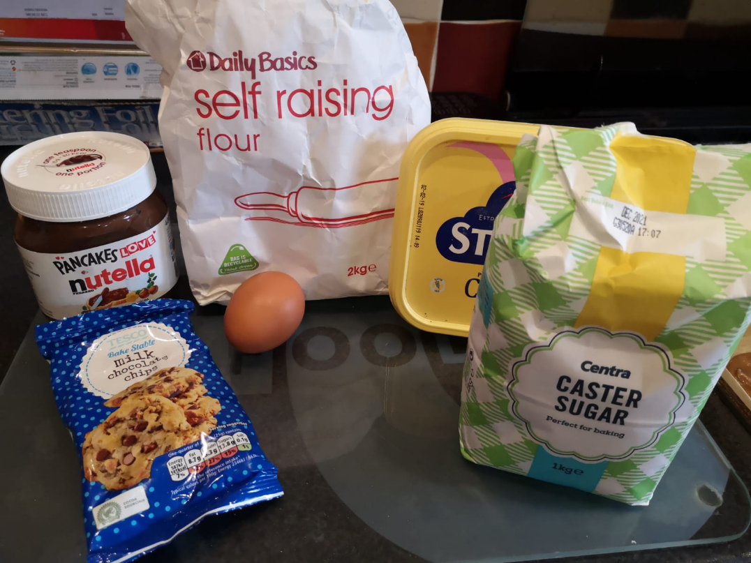

Ingredients

150g self raising flour
100g butter or margarine
50g of sugar
1 egg
50g choc chips or smarties
Method
1. Put everything in the one bowl and mix till it all comes to a dough if too wet add more flour.
2. Turn out mixture onto a floured surface and kneed till it all comes together. Roll into 12 same size balls, put on a baking sheet and flatten out.
3. Cook on gas mark 4 or 180 fan oven for 15mins.

