Play Dough Recipe 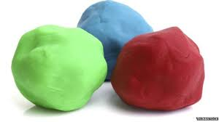

Ingredients
- 1 cup of flour (whatever kind you have on hand)
- ¼ cup of salt
- 1 Tbsp cream of tartar (optional)
- ½ cup of warm water
- Roughly 5 drops of natural food colouring

Instructions
- Mix together the flour, salt, and cream of tartar.
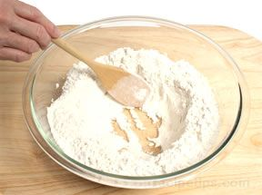
- Mix together ½ cup of warm water with a few drops of food colouring.
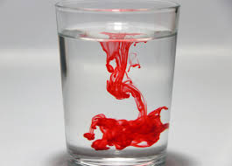
- Slowly pour the water into the flour mixture, stirring as you pour. Stir until combined, then knead with your hands until the flour is completely absorbed. If the dough is too sticky, add more flour until it doesn’t stick at all.
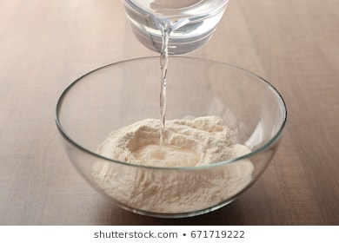
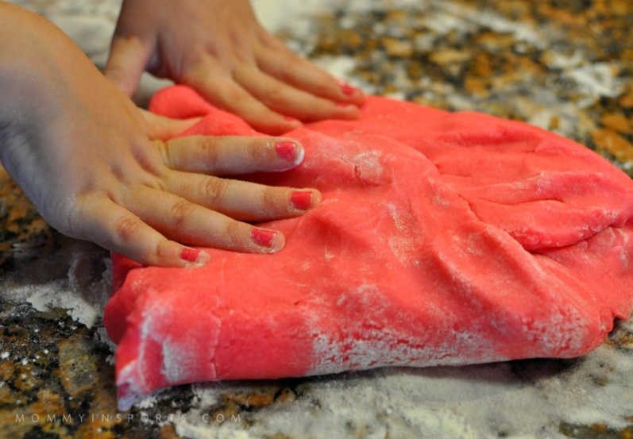

- Repeat process for whichever colours you want to make.

Notes
Mixing the food colouring with the water before combining with the dry ingredients allows you to blend them by stirring, without staining your hands.

