Water Play 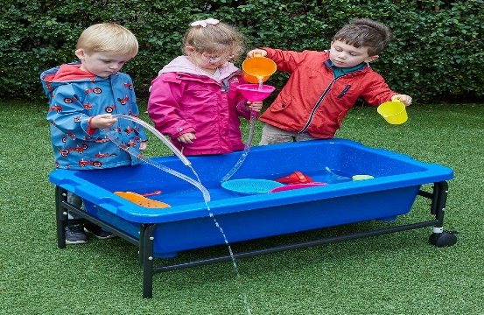

Water play is a fantastic activity that can keep children entertained for hours and very little is needed for it except for some patience, spare clothes and a loan of a few of your kitchen utensils! This is suitable for ages 3 – 10 but can be used for any age above that also.

Whats needed?
- Large bowls, pots, baby baths, paddling pools - containers of all shapes and sizes to hold the water.
- Some washing up liquid to make a few bubbles.
- Different kitchen utensils such as a colander, large spoons, a whisk, straws, jugs…..
- Other household items such as bottles of different sizes – you can punch holes in the bottles as this produces a great effect that the kids love when the water passes through them!
- Sponges, pieces of old tubing, anything that might float etc…..

Think of any utensil or item that might produce any kind of effect on water, or can move through water, sink or float……anything goes really. This is creative and experimental play.
Below are examples of things that can be used for water play;
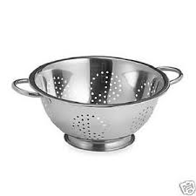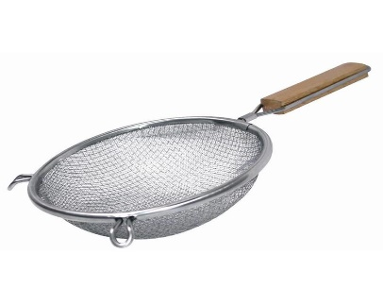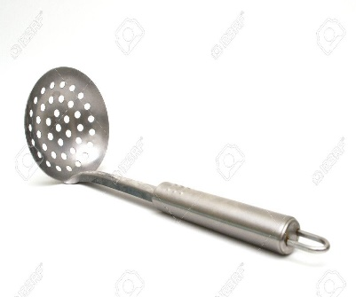

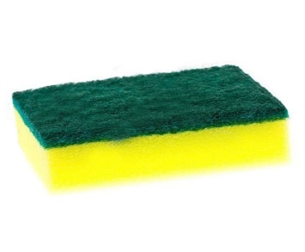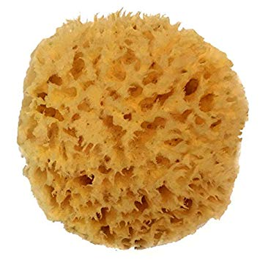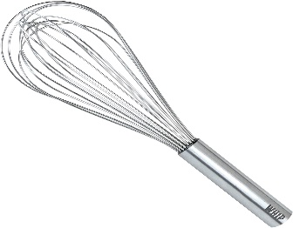

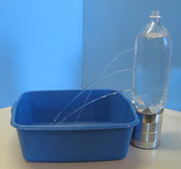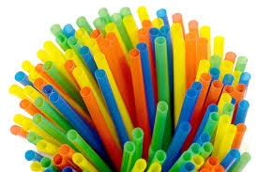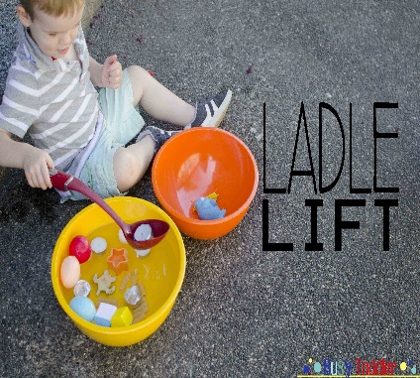

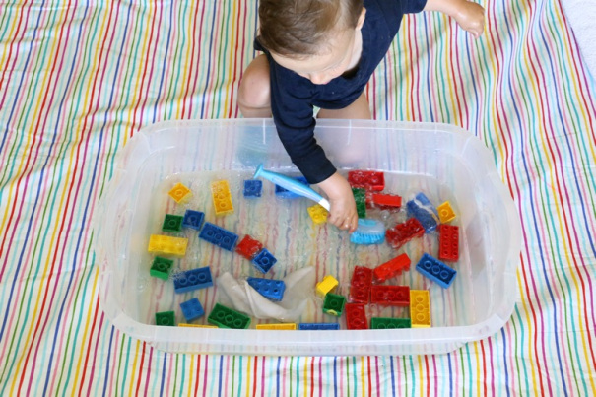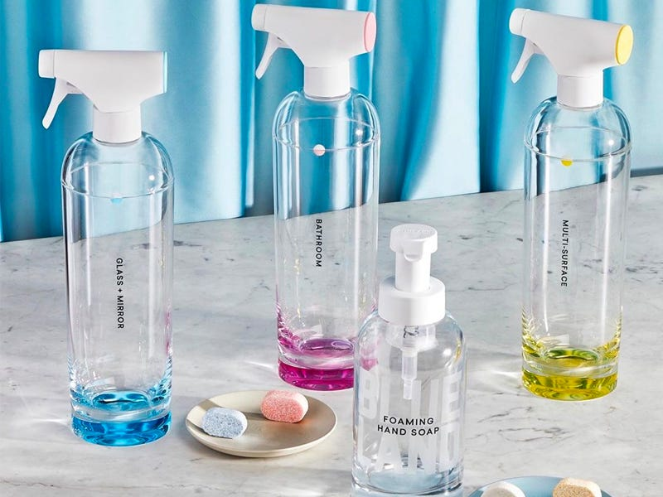

Please note;
Parents – this is an outdoor activity. Children WILL get wet. And that’s OK. Ensure they have sufficient clothing on to keep them warm but accept that water will splash, they will get wet and that this is ok. Clothes can be changed! If however you have overalls for your child then you can use these.
This is an activity that allows them to be creative, experiment, experience cause and effect relationships, explore their likes and dislikes, take positive risks, use problem solving and so much more! These kind of unstructured activities are highly valuable for children to ‘learn real life skills’.
Not to mention they’re super fun!

